Why You Need A Responsive Design In 2025
Have you ever closed a website just because it took too long to load? We all know how slow webpages can affect brand images. In this fast-paced world, everyone prioritizes speed and efficiency,

Web designs have a huge role to play here. Businesses with responsive pages for all screens always have an edge over those with slower ones. People always want fast-loading webpages and easy interfaces. Most use their mobile devices to access pages, so your web design needs to be responsive.

In 2025, having a responsive design is no longer an option, but a need. Before we discuss why you should get one, understand what it means.

What Is Responsive Design?
This is an approach where a single webpage adjusts its overall layout and functionality to different devices. This offers a smooth user experience regardless of the device being used.

This ensures ease of use and visual appeal. With techniques like fluid grids, CSS media, and flexible images, it offers a dynamic look to the site. It also provides a consistent experience and compatibility with different devices.

Reasons Why Responsive Designs Are Essential In 2025
If you're still unsure if your page needs to be responsive, here are some reasons to change your mind.

- Improved SEO Performance
Google prioritizes mobile-first indexing. Your website's ranking will be negatively affected if it isn't user-friendly. This can be a major setback since top-ranking ones are more likely to have higher conversion rates.

People choose the first few results whenever they search for a term. Google presents highly responsive pages at the top. This is important for enhanced business performance. To boost your performance, you can take help from SEO services in Ireland.

- Enhanced User Experience
Over 65% of the web's traffic comes from mobile devices like phones and tablets. Users want to see a smooth transition between devices. They expect a seamless experience. They will more likely engage with your content if the page loads fast and is easy to use. Here are some user experience benefits of mobile compatibility.

Adaptive layouts | - Content adjusts to different screen sizes.
Touch-friendly navigation | - Buttons and links are created for easy tapping.
Faster loading time | - Reduce bounce rates by loading pages quickly.

A fast web design ensures that the site is accessible and easy to navigate. This boosts user satisfaction and engagement.

- Higher Conversion Rates
Most people who visit pages from their mobile devices also make purchases. No one would buy from a site that takes too long to load. So a responsive design is essential in boosting conversion rates.

72.9% of the world's e-commerce sales happen through mobile devices. So a mobile-compatible design is important. This will prompt your audience to take action by creating a positive brand image.

- Cost-Effective Alternative
A single compatible site is better than having two different versions of the same pages for different devices. In the past, many businesses had separate designs for mobile and desktop. This was highly inconvenient.

However, today, with a responsive design, you can save yourself from having to maintain two pages. In addition to this, you can easily implement new updates that save resources. It costs half the amount to maintain one than having two different versions.

- Boosting Brand Image
Think of your webpage as the face of your brand. You want it to impress your customers. A poorly designed site will only create a negative image for you. So you need to offer a smooth navigation experience with yours.

- According to a recent survey, 79% of users said that they revisited a site because it was mobile-friendly.

A fast, mobile-compatible design shows your professionalism and dedication to customer satisfaction. Pages that load easily do not just provide a better user experience. They also create a consistent, impressive brand identity.

- Easier Adaptability
The digital world is always changing. New devices and technologies keep emerging. One factor that sets successful designs apart from others is their ability to adapt to these changes. As user needs shift, your page should be able to change accordingly.

A well-designed site can easily adjust to such changes and offer a smooth experience across different devices. If you're confused about how exactly it's done, you can consult a responsive website design company.

- Social Media Linking
Social media plays a huge role in improving business performance. By driving online traffic from the profiles to your website, it boosts visibility. Users are more likely to stay on your page if it loads faster and has a good display. So social media linking can be a game-changer for driving organic traffic.

Here's a visual representation of the amount of traffic that websites receive from different channels. 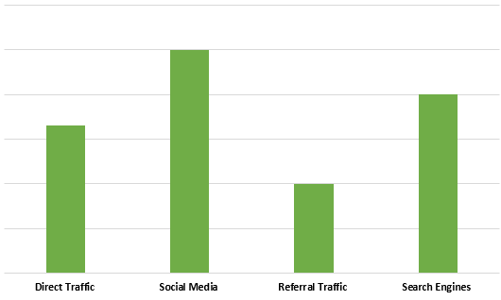

In addition to this, responsive sites also allow for easier sharing and interaction. This encourages users to engage more. This makes high responsiveness even more important for businesses that opt for social media marketing.

People Also Ask
- Can I convert my existing website to be mobile-compatible?
Yes, but the process depends on the complexity of the existing site. You may need to rewrite the HTML and CSS. In some cases, it might be better to get a new website made from scratch instead of revamping the old one.

- How is this design different from adaptive ones?
They both aim for a mobile-friendly experience, but by using different methods. Responsive design uses one layout that adapts to different screen sizes. On the other hand, the adaptive one shows a uniform layout based on the device.

- How do I know if my website is responsive?
You can test it by resizing your browser window to check if the layout adjusts easily. You can also use your browser's built-in developer tools or online testing tools.

Conclusion
In today's fast-paced world, users prefer pages that take no time to load. This is important for businesses that want to stand out from the rest in 2025. With a mobile-compatible site, you can offer your audience a smoother user experience.

In addition to this, a well-designed website will also contribute to your brand image. With smoother navigation, you can improve your SEO performance and boost conversions. This is also a cost-effective alternative to having multiple versions for different devices.

A mobile-compatible design also helps drive more traffic and ensure customer retention.
